**OUR SERVICES**

* stand-alone solar street & security light
* electrical back-up / solar hybrid / stand alone solar systems
* Integrated Power Solution
* Solar Power for Electronic/Close Circuit Security Camera (CCTV)
* Solar Water Pump for Homes/Communities
* Medical and Laboratory EQUIPMENT
* Cathodic Protection Services
* Solar Power for Office Appliances
* Industrial Computer Based Machines
* Office/Domestic Appliances
* Lightning Arrestors, Surge Protectors, Earthing

**STAND-ALONE SOLAR SYSTEM**

This refers to a complete solar system comprising photovoltaic (PV) Modules, charge controllers, storage batteries, inverters and all installation materials/accessories, for areas where the national grid (PHCN) is non-existent and the use of generator not convenient.

It is ideal for unmanned equipment especially in inaccessible terrain.

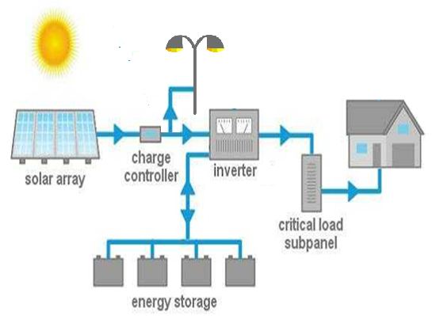

**ELECTRICAL BACK–UP SYSTEM**

This is a combination of Inverter, PHCN/NEPA and Generator. The energy stored in the batteries are charged from the central grid and/ generator.

This system is ideal for domestic use in homes, offices, ATMs, Banks, schools, supermarket, hotels, e.t.c.

**Applications**

* Telecommunication Network System
* Electrical / HYBRID/ STAND ALONE SYSTEM
* Data/Call Centers
* Critical Work Stations
* Solar Powered Street/Security Light
* Office/Domestic Appliances
* Security Alarms Systems/Lighting
* POS Systems/Air conditioners
* Medical/Laboratory EquipmentS
* Repeater Stations/SignageS
* Data/Call Centers/Bill Boards

**Product Line**

* Stand Alone Solar Street Light
* Electrical Backup System
* Solar Powered Borehole
* Solar Photovoltaic Modules 80w – 300w
* Solar Charges Controllers
* Maintenance Free Batteries
* Battery Chargers 12V-48V
* DOUBLE CONVERSION Online UPS 1 – 600KVA
* offline/online pure sinewave inverters 1 – 100kva
* DC-AC Pure Sine Wave Inverter
* AC-DC-AC Pure Sine Wave Inverter
* Offline UPS Inverter 600VA-400KVA
* Solar Vaccine Refrigerator

Our Partners

1. Multipower
2. Starplus
3. Felicity Solar
4. D2H
5. Solarworld
6. Machtig
7. Royalpower
8. Mega Power

Registered office

Road 208, “C” CLOSE, HOUSE 9, FESTAC TOWN, AMUWO ODOFIN, LAGOS.

E-mail: [seapslimited@gmail.com](mailto:seapslimited@gmail.com)

Facebook: Solar Energy Power Trans

Instagram:@SoNergy